MARQUAND READER
Volume 15, Issue 9: Week of November 1, 2015
The Newsletter of Marquand Chapel at Yale Divinity School

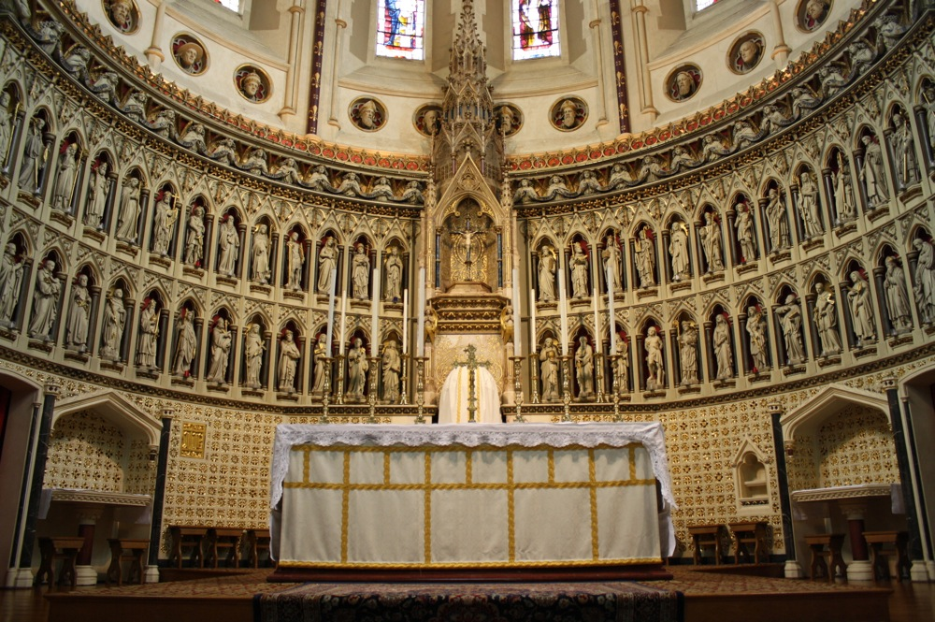

Monday, November 2: On Monday we commemorate the ancient Christian festival of All Saints and the memorial of All Souls, both of which were fully adopted into the Western Church by the eleventh century. Though the reforms of the sixteenth century changed the way many people think of saints, the departed, and our ability to intercess for one another, many Reformed and Protestant Christians still recognize these two days as a Major Feast and Principle Holy Day. So how to approach these two days?

“Saints are Christians who in various ways, often against great odds, showed an extraordinary love for Christ. The Holy Spirit acted in their lives so that they chose to bring aid to the needy, justice to the oppressed, hope to the sorrowful, and the divine word of forgiveness to sinners. For the sake of Christ they were servants to the people of their day; and the service they rendered in the past makes them examples to the rest of the people of God throughout history. . . . It is the Church’s Conviction . . . that the saints continue to be our partners and fellow-servants before the face of God’s glory. We pray for our present needs, and the saints pray with us — not as if their prayers were better than our own, but because they are still bound to us in mutual service as members of the one body of Christ. . . . The Ministry of the saints in heaven as on earth [is] to help others become partners in the salvation of God.” In the same way, All Souls Day is an opportunity to “remember all those who have touched our own lives, and the men and women of our own community whose good works have sustained and enhanced the ongoing life of our Christian community.”
Many churches acknowledge the continued presence of the saints, and of the departed, among us with the reredos (pictured on the front page), a decoration behind the altar which often depicts biblical and other historical saints. On Monday we will create our own reredos for Marquand Chapel to honor the saints in our own lives.

To this end, we will be asking the YDS community to submit pictures and names of people who have had had an impact on them, and who we continually ask to join us on our journey of faith. The link has been made available over DivMail.

– Quoted text from For all the Saints: Prayers and Readings for the Saints’ Days, compiled by Stephen Reynolds, (Toronto: Anglican Book Centre, 2007), 328, 330.

Thursday, November 5: Open House for Prospective Students!
Professor and Preacher, Dr. Nora Tubbs Tisdale will be preaching from the book of Ruth.
Today is also the day we welcome prospective students to the Quad.

Friday, November 6: This Friday we will gather for our Community Eucharist in the worship style of downtown New Haven’s “Table on the Green.” Striking a chord with ancient worship, we share God’s Feast amidst a larger meal. The Rev. Kari Henkelmann Keyl, pastor of Luther House in downtown New Haven, will preside and graduating student, Kristian Kohler, M.Div ’16, will preach.

THIS WEEK IN MARQUAND
Services begin at 10:30 a.m. All are Welcome!

Monday November 2: All Saints and All Souls. Honoring the Saints in our lives.

Tuesday November 3: A Service of the Word, graduating student, Alissa Kretzmann, preaching.

Wednesday November 4: Morning Prayer from the Northumbria Community.

Thursday November 5: A Service of the Word, Prof. Nora Tubbs Tisdale, The Clement-Muehl Professor of Homiletics, preaching.

Friday November 6: Community Eucharist in the style of “Table on the Green.” The Rev. Kari Henkelmann Keyl, pastor of Luther House in downtown New Haven, presides. Kristian Kohler, M.Div ’16, preaches.

The Marquand Chapel Team
Dean of Chapel | Maggi Dawn
Director of Chapel Music (Interim) | Wesley Hall
Gospel and Contemporary Ensemble | Mark Miller
Liturgical Coordinator | Christa Swenson
Chapel Ministers | Alissa Kretzmann, Kevin McKoy, Justin Mikulencak, Zack Nyein, Joshua Sullivan, Liesl Spitz, Susan Wentzy
Liturgical Assistant | Katie McNeal
Research Assistant | Robert Laughton
Chapel Choir Directors | Sarah Paquet and Patrick Murray
Organists | Bradley Burgess

