MARQUAND READER
Volume 15, Issue 11: Week of November 15, 2015
The Newsletter of Marquand Chapel at Yale Divinity School

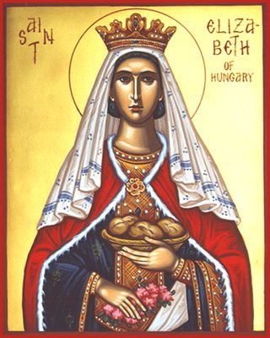

Monday November 16: Rest for your Souls. Start the week with an uplifting service of prayer and song, drawn from the Wee Worship Book.
Tuesday November 17: We Are Many. Graduating student Brian Kelly will explore the story of Legion of the Gesarenes. With music from Mark Miller and the Marquand Gospel and Contemporary Ensemble.
Wednesday November 18: Songs and Stories from the Stoop Come and share in songs and stories from our community.
Thursday November 19: At today’s service, we remember Elizabeth of Hungary, a thirteenth-century princess who devoted her short life to serving the poor, the sick, and the homeless.
She was born in 1207 and at the age of fourteen became the wife of Ludwig, the ruler of Thuringia. Their marriage was happy and with her husband’s support Elizabeth not only cared for their own children but also found time to supervise various projects for the aid of the poor. She founded several hospitals and homes for the elderly, and provided shelters for orphans and abused children. But then Ludwig died, and her brother- in-law drove her from the royal court. Elizabeth joined the Franciscans as a lay-associate and adopted a life of poverty. She did menial labor in the very hospices that she had founded and went into the homes of poor people to help them with their daily tasks. Love for Christ kept her going in the most brutalizing conditions, but in 1231 she succumbed to overwork and a sudden virus. She was only twenty-four when she died.
The people of Germany immediately began to venerate her, and she was declared a saint of the Church within four years of her death. Even today, many hospitals throughout the world bear her name, in memory of her devotion to binding up the wounds of suffering humanity.

Text taken from For all the Saints: Prayers and Readings for the Saints’ Days, compiled by Stephen Reynolds, (Toronto: Anglican Book Centre, 2007), 352.

Friday November 20 As we meet for our last Community Eucharist before Thanksgiving, we will reflect on thanksgiving and feasting on God’s word.

THIS WEEK IN MARQUAND
Services begin at 10:30 a.m. All are Welcome!

Monday November 16: Rest for your Souls.

Tuesday November 17: Graduating student Brian Kelly preaching. Music led by Mark Miller.

Wednesday November 18: Songs and Stories from the Stoop.

Thursday November 19: The Feast of Elizabeth of Hungary. With music led by Henry Parkes and members of Marquand Chapel Choir.

Friday November 20: Community Eucharist. Maggi Dawn presiding; graduating student Jonathan White preaching.

The Marquand Chapel Team
Dean of Chapel | Maggi Dawn
Director of Chapel Music (Interim) | Wesley Hall
Gospel and Contemporary Ensemble | Mark Miller
Liturgical Coordinator | Christa Swenson
Chapel Ministers | Alissa Kretzmann, Kevin McKoy, Justin Mikulencak, Zack Nyein, Joshua Sullivan, Liesl Spitz, Susan Wentzy
Liturgical Assistant | Katie McNeal
Research Assistant | Robert Laughton
Chapel Choir Directors | Sarah Paquet and Patrick Murray
Organists | Bradley Burgess

