MARQUAND READER
Volume 15, Issue 14: Week of January 17, 2016
The Newsletter of Marquand Chapel at Yale Divinity School

This week in Marquand

Tuesday January 19 A Service of the Word.
Nicholas Lewis, Associate Dean for Student Affairs, preaching. Music led by Mark Miller and the Marquand Gospel & Inspirational Ensemble.
Wednesday January 20 A Service of the Word for the Season of Epiphany
Rev. Washington (Tony) Jarvis, preaching
Thursday January 21 Sung Morning Prayer: Songs of the Americas
Friday January 22 Community Eucharist
Rev. Bonita Grubbs will preach, and preside at the Table.
Rev. Grubbs is the Executive Director of Christian Community Action, a faith-based not-for-profit ecumenical social services agency in New Haven, providing needed assistance to the poor and homeless.

Wednesday January 20, 12:30 pm
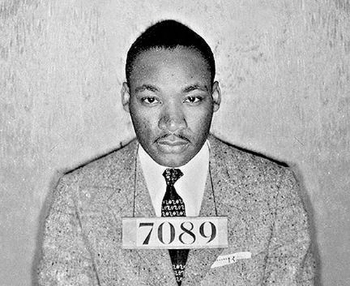
Prayers of the People | A Rite of Responsibility honoring Dr. Martin Luther King, Jr.
A public ritualistic reading of Letter from Birmingham Jail,
adapted and hosted by little ray.

Kenyon Adams, who writes and performs under the name “little ray”, is Artist in Residence at the ISM, and Director of Arts Initiatives at Grace Farms Foundation.

THIS SEMESTER IN MARQUAND

Welcome back! I hope you have had time to take some rest over the break, and are ready for the challenges and joys of a new semester.
Over the break I was chatting with a student who worships regularly in Marquand. “What’s most important to you about Marquand,” I asked. “To me,” he said, “it’s that whatever struggles, “lightbulb” moments, challenges, arguments or inspirations we’ve encountered in the classroom, in Marquand we know we can come together again, even though we know we don’t agree about everything. In fact, maybe it’s finding that we can worship together with people we don’t agree with that makes it so powerful.” I felt he summed up beautifully the reason it is worth working through the struggles of being an ecumenical community: we intentionally come together with people who don’t think, sing, speak or worship exactly like us, and we embrace the discomfort that often produces in us, for the sake of knowing and worshipping our God, who is bigger than any format, liturgy, sermon or song that we can create. As we do, the joyful result is that we find the presence of the Holy Spirit in each other. As our world faces ever more frightening conflicts and divisions, I believe this endeavor is of far greater significance that merely making us feel good in the middle of each morning. We need to learn how to live creatively and lovingly with people who are different from us, and to recognize and welcome the spirit of God in each person we meet.
This semester, we invite you once again to be part of this community of worshipers. Bring your own gifts and points of view; come ready to share them, and to receive from others. Together we can discover what binds us together; together we can rejoice in our differences that make our community interesting and diverse.
We are looking forward to a semester that includes, among other modes of worship:
- sermons and reflections from Faculty, Staff, and senior students
- visiting preachers, including Pastor Amy Butler, Rev. Aracelis Vasquez Haye, Rev Ian Cron, Carolyn Woo, and Dr Daisy Machado
- Prayers of the People | A Rite of Responsibility honoring Dr. Martin Luther King, Jr adapted and hosted by ISM Artist in Residence, little ray
- visiting Ritual Artist, Ted Lyddon Hatten
- visiting comedians Susan Sparks and Nick Mosca
- visiting storytellers Reggie and Kim Harris
- organist Jeremiah Wright-Haynes is re-joining our resident musicians
- services created and led by student volunteer groups
- Café Worship – we had such good responses to this last semester we’ll develop this form further
- Paperless singing, including a visit from Donald Schell, from Music Makes Community

All this and much more. Every day is a little different, so as always, to get the most from Marquand come as often as you can, and stay awhile, even if it’s not your kind of “normal”.
Rev’d Dr Maggi Dawn, Dean of Marquand Chapel

The Marquand Chapel Team
Dean of Chapel | Maggi Dawn
Director of Chapel Music (Interim) | Sara O’Bryan
Gospel and Contemporary Ensemble | Mark Miller
Liturgical Coordinator | Christa Swenson
Organists  Chapel Ministers | Wesley Hall, Jeremiah Wright-Haynes  Alissa Kretzmann, Kevin McKoy, Justin Mikulencak, Zack Nyein, Robert Laughton, Joshua Sullivan, Liesl Spitz, Susan Wentzy
Liturgical Assistant | Katie McNeal
Student Chapel Choir Directors | Sarah Paquet and Patrick Murray
Organ Scholars | Bradley Burgess, Janet Yieh, Evan Cogswell

The Marquand Advisory Committee

Peter Hawkins (Chair)
Janet Ruffing
Chloe Starr
Nicholas Lewis
Jeremy Williams
Green Bouzard

