MARQUAND READER
Volume 15, Issue 18: Week of February 14, 2016
The Newsletter of Marquand Chapel at Yale Divinity School
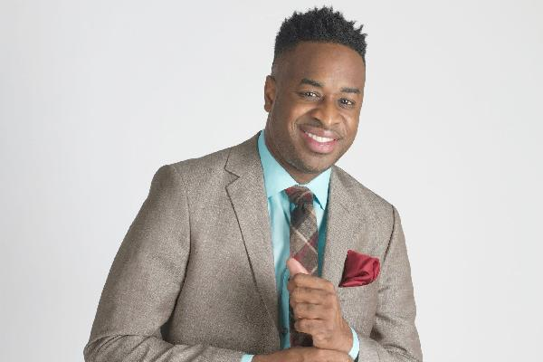

Special Guest, Damien Sneed
Damien Sneed is a multi-genre recording artist and a 2014 recipient of the prestigious Sphinx Medal of Excellence honor, which is presented annually to emerging Black and Latino leaders in classical music, Sneed has also garnered attention in a wide range of other musical genres, including jazz, gospel, pop, R&B, and musical theatre. He has been featured in the New York Times multiple times for his work in various genres. He has served as music director for GRAMMY® Award-winning gospel artists, including The Clark Sisters, Richard Smallwood, Donnie McClurkin, Hezekiah Walker, Marvin Sapp, Karen Clark Sheard, Dorinda Clark-Cole, and Kim Burrell. He also served as musical director for season four of Sunday Best, Black Entertainment Television’s (BET) hit award-winning gospel singing competition show. In May 2015, he was tapped by Tony Award winner, George Faison as the musical director and conductor for the City Parks Foundation’s Central Park’s Summer Stage production of “The Wiz: A Celebration in Dance & Music.” He is a graduate of John S. Davidson Fine Arts School, and he has studied at some of the finest conservatories and universities, including Howard University, where he earned a Bachelor of Music – Piano Performance; the Peabody Conservatory of Johns Hopkins University; New York University, where he earned a Master of Music in Music Technology: Scoring for Film and Multimedia; and the Manhattan School of Music. In 2010, he was presented with an Honorary Doctorate of Sacred Music from the Christian Bible Institute and Seminary.
- Photo and biographical information taken from www.damiensneed.com

Damien Sneed will be leading the rehearsal for the Marquand Gospel and Inspirational Ensemble on Monday evening at 7:00 pm – ALL ARE WELCOME to join in for this evening. He will lead worship in Marquand on Tuesday morning.

Thursday Worship Jam 12:30-1:20
Are you interested in helping to plan Thursday Sung Morning Prayer services? Are there songs, hymns, or readings that are dear to your heart that you’d like to sing and hear in chapel? Are you interested in leading music in chapel, or looking to learn how to lead paperless music? Please come to Marquand Chapel on Thursday afternoons for an informal session (even though it’s reading period).

Musician Mondays
We’re looking for musicians to help lead music in Marquand Chapel, particularly on Mondays. This includes pianists for this day! Every Monday, the Director of Chapel Music, Sara O’Bryan will be in chapel at 9:30am to rehearse the hymns for that day’s service. She will bring sheet music parts, music stands, etc. for any instrumentalist who is available to play. You don’t have to be a world-renowned virtuoso musician to help; all are welcome! Please email sara.obryan@yale.edu to let her know if you are interested in playing, and if you’d like the music in advance; she would be happy to send it your way. This is not an every Monday commitment; we’ll take it week by week for whoever is willing and able to be there. Many thanks for your help!

THIS WEEK IN MARQUAND
Services begin at 10:30 a.m. All are Welcome!

Monday February 15: A service of the Word with graduating student Bailey Pickens, M.Div ’16, preaching.

Tuesday February 16: Music by the Marquand Gospel and Inspirational Choir led by special guest, Damien Sneed.

The winter reading period begins Wednesday February 17. Whether you’re staying in New Haven, visiting family and friends, or going away on we retreat, we hope and pray that you have a restful break and return to us on feeling revived for the week ahead.

The Marquand Chapel Team
Dean of Chapel | Maggi Dawn
Director of Chapel Music (Interim) | Sara O’Bryan
Gospel and Contemporary Ensemble | Mark Miller
Liturgical Coordinator | Christa Swenson
Organists | Wesley Hall, Jeremiah Wright-Haynes
Chapel Ministers | Alissa Kretzmann, Robert Laughton, Kevin McKoy, Justin Mikulencak, Zack Nyein, Joshua Sullivan, Liesl Spitz, Susan Wentzy
Liturgical Assistant | Katie McNeal
Chapel Choir Directors | Sarah Paquet and Patrick Murray
Organist Scholars | Bradley Burgess, Evan Cogswell, Janet Yieh

The Marquand Advisory Committee
Peter Hawkins (Chair)
Green Bouzard
Nicholas Lewis
Janet Ruffing
Chloe Starr
Jeremy Williams

